Appendix to Uachtarán & Ard Stiúrthóir correspondence
What we need to continue to do
- Continue to follow Public Health guidelines
- Practice good hygiene by washing our hands and using sneezing and coughing etiquette
- Wear face masks where appropriate to do so
- Follow GAA protocols by not using changing rooms, dug-outs or other enclosed spaces
- Indoor meetings should be avoided as they both increase the risk of transmission and also make every attendee a ‘close contact’ and subject to quarantine should a positive case arise
- Gyms on GAA property should also remain closed
- Travel to training / matches with members of our own household only
- For training and games, we must submit a Health Questionnaire or reconfirm that our health status hasn’t changed on each occasion that we attend. This can be done using the Return to play application (https://returntoplay.gaa.ie)
- Covid Supervisors in clubs must ensure that Health Questionnaires have been completed
- Attendance at training should be recorded to facilitate contact tracing – functionality to do this is available on the Returntoplay application
- Do not travel to watch games if feeling unwell
- If attending matches as a spectator, do not enter the playing field before, during, at half-time or full-time
- Spectators should still maintain social distancing at matches
- Spectators should keep a record of who they were in contact with at matches in the event the information is necessary for contact tracing subsequently
- Members who arrive back in Ireland from a country not on the government's green travel list should follow Government advice in this context (i.e. restrict their movements for 14 days) and are not permitted to present for GAA activities until the 14 days has elapsed.

Return to Play Application
Below is a brief recap on how to use the Return to Play Application including some improved functionality for filtering individual teams and recording attendance
Players / Parents
- Register for the application on https://returntoplay.gaa.ie if you have not already done so
- Select your club from the drop down options.
- You can select multiple ‘clubs’ if you or your child is involved with more than one club or independent team. You can also select LGFA, Camogie, Handball or Rounders options, if relevant.
- If attending a Cúl Camp, the relevant camp can also be selected from the drop-down options.
- Complete a Health Questionnaire for the relevant team - you must do this for each team that you or your child is involved with.
- Reconfirm that your health status is unchanged for each subsequent training session or game. This must be done on the day in question, it should not be done the day before.

CoVID Supervisors
- Register for the application on https://returntoplay.gaa.ie if you have not already done so and select your club from the drop down options.
- Ensure that you indicate that you are a CoVID Supervisor in your profile.
- Ensure that your club executive has submitted your email address via the form (available here) so that you can be granted access to view Health Questionnaires for your club. Please note that this email address must be the one that you used to register on returntoplay.
- When logged in to the system, you will be presented with a list of Health Questionnaires submitted for your club.
- You can filter this list to the relevant team(s) by using the filter options available.

Figure 1- Filter Option Figure 2 – Date & Team selection Figure 3 – Record Attendance
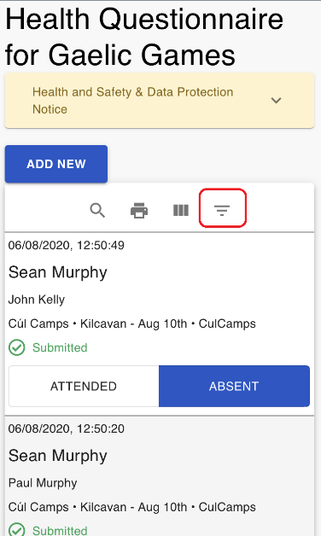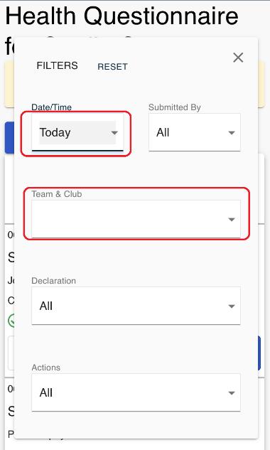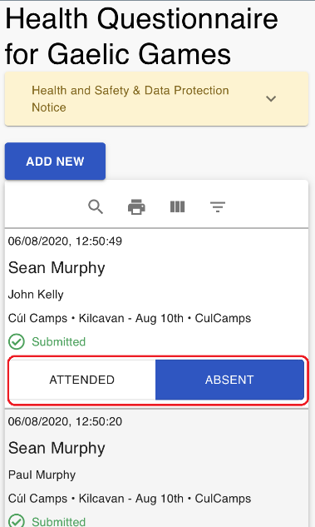

- You can also filter to show players who have submitted for today only
- It is also possible to mark players present or absent as relevant
- Players who have not submitted the relevant Health Questionnaire / reconfirmation should not be permitted to play until they have done so
- The functionality above is mobile responsive and can be completed on your mobile phone
- Please note that rotating your phone to use a landscape view is recommended
Figure 4- Landscape view on a mobile device
