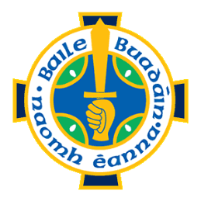
Football Committee 2019.

Name Function. Telephone number e-mail.
Jack Nolan Chairman 0872366622 jack@cruinn.ie
Shay Devlin Vice Chairman 0862540881 shaydev697@gmail.com
John Madden Secretary 0872905396 football@ballyboden.ie
Denis Molony C.C.C. Delegate 0879582060 denneedennee@yahoo.ie
Donie Kerin Delegate to County Board. 0872100070 doniekerin@gmail.com
Neil Buckingham Adult Football P.R.O. 0879710737 footballpro@ballyboden.ie
Pat Walsh Comm Member-Gear. 0872373202 patrickj.walsh@gmail.com
Frank Brooks Comm Member- Facilities. 0868285384 frankmbrooks@gmail.com
Tony Basquel Comm Member-Fundraising 0877982895 tonybasquel@hotmail.com
Liam Deane Comm Member- Fundraising 0876471121 Liam.Deane@teagasc.ie
Helen Deignan Comm Member-Finance 0862272598 hpdeignan@gmail.com
James McGarry Comm Mem-Player tracker 0868394111 james.mcgarry@iko.ie
Jim Keane Comm Mem-Player tracker 0879878433 jimkeane@kci1.com
Conor Doolan Comm Mem-Injuries. 0851743808 Conor.Doolan@eir.ie
Brendan Gillespie Comm Member 0879081411 brengill1@gmail.com
Brendan Timbs Comm Member 0866084615 darbytimbs@gmail.com
Tony Duffy Comm Member 0877735105 atduffy1@gmail.com
Tommy Flynn Comm Member 0868525951 tandtflynn@cmail.com
Pat Doyle Comm Member 0862487274 info@nationalguild.ie
Cormac o Farrell Comm Member 0879396024 cormac_o_farrell@hotmail.com
Neil Brennan Comm Member 0878386458 neiljbrennan@gmail.com

