7 Lúnasa, 2020

A chairde,

The past few weeks has seen the return of competitive action across the country with club hurling and football championships in full swing. Cúl Camps have also made a welcome return and will continue until schools reopen at the end of this month.

This restart of GAA activity has only been possible due to the hard work and diligence of club volunteers in every county adopting and implementing the GAA Return to Play protocols, as published by the CoVID19 Advisory Group, in line with Government and Public Health Guidelines.

A huge debt of gratitude is owed to each and every member involved and for this, the Association would like to say a heartfelt ‘go raibh maith aghaibh’.

However, the spectre of the pandemic still hangs over us all and the virus is still present in our country. There are still risks to our communities and, in particular, to the most vulnerable people in our society, and consequently we must continue to adhere to the public health guidance and to follow the protocols that have been put in place.

We do not underestimate the disappointment being felt by club members who cannot get to see club matches because of the restrictions on outdoor gatherings – particularly in the 26 Counties where it remains at 200.

The Association has demonstrated to the Government how increases in attendances outdoors of up to 500 can be easily accommodated and managed at GAA venues.

We will continue to make those representations but, in the meantime, it is important that members continue to show the exceptional community leadership that you have shown since last March in helping Ireland combat this virus.

We have managed to get training and games back. We must try and ensure that we do what we need to do to keep activity back on our fields.

Any complacency about what has been achieved to date could see a resurgence in the virus and a return of the restrictions that impacted us all so heavily earlier this year. It is imperative that every one of us realises the important part we each have to play in keeping our communities safe. Please read and circulate the appendix attached, which is a reminder of the important points that we need to continue to do.

Ní neart go cur le chéile.

Míle Buíochas,

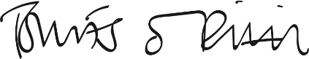

Tomás Ó Riain, Ard Stiúrthóir CLG

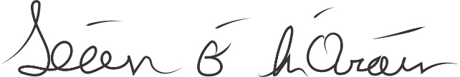

Seán Ó hÓráin, Uachtarán CLG

